Competing on Data, Analytics and Business Performance with Internal and External Processes

Ashish V. Tambadkar

Stevens Institute of Technology

MIS-630

Professor Joseph Morabito

**Table of Contents**

1. Introduction 4
2. Definition 5
   1. Data Analytics 5
   2. Business Intelligence 6
   3. Business Performance 8
3. Application Domain for Analytics 9
4. Competing on Data, Analytics & Business Performance with Internal Processes 10
   1. Financial Analytics 10
   2. Manufacturing Analytics 11
   3. Research and Development Analytics 12
   4. Human Resources Analytics 13
5. Competing on Data, Analytics & Business Performance with External Processes 13
   1. Customer Based Process 15
6. Things you can count on 17
7. Conclusion 18
8. References 19

**Abstract**

This paper focuses on delivering competitive advantage to companies using data, analytics and business performance, also transforming a company into such a way that it has improved operational efficiency and is ready to grab any new market opportunity. It also describes the importance of Business Intelligence and Data Analytics have on a company to help a company evolve as the time goes by.

**Keywords:** Data Analytics, Business Intelligence, Business Performance, big data.

**Introduction**

In today’s time a business can only be tagged as successful if your customers are satisfied with what you have to offer, so in order to continue satisfying your customer you as a business have to know what factors contribute in satisfying those customers as well as what are the factors which can satisfy them even more in near future and this is where Data, Analytics, and Business Performance comes in the picture. Creating a record of business activities and customers response on paper or in form of electronic media results into formation of data which can be then analyzed and used in such a way that we can embed intelligence and create a model which reflects a pattern enabling us to know how the business is working out and based on that feedback we can evolve any business into an efficient and satisfying one for the customers

To create an effective process is where business performance management comes in spotlight, in case of business performance management, you set a goal, then do information monitoring and once that is done you do a managerial adjustment like focusing on increasing efficiency and profitability thereby reflecting company’s goal.

To be a lead company, Data Analytics and Business Intelligence should be at its core in a company. Analytics support for business in both internal as well as external processes is something that’s going to help a company remain on top and hence it is one of the important things a company should look at continuously for better and improved results. Albeit various associations are grasping investigation, just a bunch have accomplished this dimension of proﬁciency. Be that as it may, examination contenders are the pioneers in their shifted ﬁelds—consumer items, ﬁnance, retail, and travel and excitement among them. Some companies have built their very businesses on their ability to collect, analyze, and act on data. Every company can learn from what these firms do [1]. This paper concludes with why you need analytics and what you will be facing ahead and how to manage company more effectively and efficiently.

**Definition**

Data Analytics

Data Analytics alludes to subjective and quantitative systems and procedures used to improve efficiency and business gain. Information or Data is extricated and sorted to recognize and break down conduct information and examples, and procedures shift as per authoritative prerequisites.

Some Unique Characteristics of Big Data Big data exhibits a range of characteristics that appears to be unusual when compared to traditional datasets. Traditionally, datasets were generated upon conscious and careful planning. Field experts or laboratory experimenters typically spend considerable time, energy, and resources to produce data through planned surveys or designed experiments. However, the world of big data is often nourished by dynamic sources such as intense networks of customers, clients, and companies, and thus there is an automatic flow of data that is always available for analysis. This almost voluntary generation of data can bring to the fore not only such obvious issues as data volume, velocity, and variety but also data veracity, individual privacy, and indeed, ethics [2]

Information or Data investigation is essentially led in business-to-consumer (B2C) applications. Worldwide associations gather and investigate information related to clients, business forms, showcase financial matters or handy experience. Information is arranged, put away and investigated to ponder buying patterns and examples.

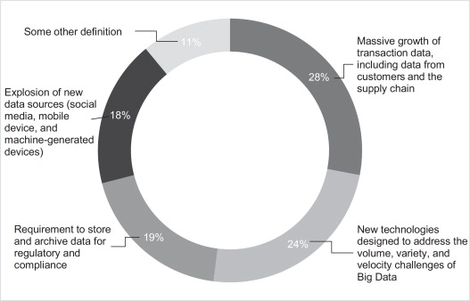

Fig1 Definitions of big data based on an online survey of 154 global executives in April 2012[3]

The Purpose of this Information is to let us know about Data Analytics and why it is so important for a company. We will also look after the definition of Business Intelligence and Business Performance.

Business Intelligence

To Better Understand What Business Intelligence is, below diagram best describes what Business Intelligence is

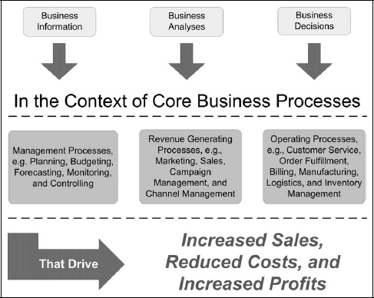

Fig2 Describes Business Intelligence in practice. Adapted from The Profit Impact of Business Intelligence, By Williams, Steve Williams, Nancy, 2007

In the course of recent decades, there has been a stupendous progress with respect to the creation, accumulation, and utilization of information. While incredible steps have been made in information the board, there is dependably the longing to extricate business esteem covered up inside the heaps (or rather "mountains") of bits and bytes that today are put away inside organized information frameworks as well as are caught, put away, oversaw, shared, and dispersed crosswise over various document designs, agent structures, and even as unstructured information resources.

Be that as it may, suppose you had the ability to sift through and convey the jewels of information to the correct chiefs that can trigger the correct sorts of decisions and activities at the ideal occasions. For instance, suppose you could:

* Identify who your organization's best clients were, anticipate the measure of money they would spend throughout the following three months, and draw in your best business people to contact those clients;
* Automatically survey worldwide ware costs and progressively balance high total assets customer venture portfolios to decrease chance while keeping up a high rate of return;
* Continuously audit item benefit and kill the most exceedingly terrible performing things from the inventory;
* Compare provider execution dependent using a credit card value, item accessibility, consistency with contract terms, and item estimating to lessen the quantity of affirmed sellers;
* Figure out underserved geographic areas and the relative expenses for entering nearby markets to recognize best open doors for development;
* Monitor key viewpoints affecting consumer loyalty among a gathering of conventional sources combined with web-based life streams to recognize and right issues in a quick and viable way; or
* Provide precise review trails showing administrative consistency to anticipate fines and awful exposure.

Every one of these situations shares key attributes: the aftereffects of breaking down information propose activities for explicit individual jobs that can prompt a business advantage. What's more, these are only a couple of instances of the sort of information that can be uncovered and misused utilizing business insight (BI). There is critical esteem implanted inside the accumulation of sets of data available to us, holding up to be found and abused. Be that as it may, to get to this concealed fortune, we should initially change the way we consider information, data, and eventually, significant learning. Today, and for a long time to come, information utility extends to help operational exercises and additionally strategic and vital choices [5]. All this above information clearly indicates why business intelligence is so important for a company

Business Performance

Business performance management is the demonstration of defining corporate objectives, checking the strategies used to accomplish those objectives, and after that making courses for supervisors to more viably accomplish those objectives. By gathering and breaking down information, an organization can figure out what impacts administrative changes had on execution and afterward modify those progressions to help make a progressively compelling procedure. The possibility of business execution the board is a wide idea, yet it is best used to break down explicit objectives and help an organization to save money on working expenses while producing more income in the meantime. The critical thing to recollect about business execution the executives is that it is utilized to enhance the execution of staff and the board. Business process management (BPM) coordinates most of an association's business procedure to make singular procedures increasingly proficient. BPM can be used to solve a solitary glitch or to make one bring together framework to solidify a horde of procedures. Numerous associations are discontent with their present blend of programming applications, what's more, managing business forms that are liable to steady change. These associations are swinging to BPM frameworks that can adaptably computerize their procedures also, stick their endeavor applications together [6].

**Application Domain for Analytics**

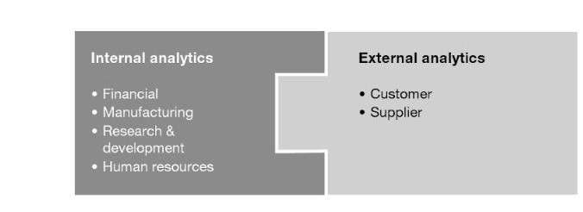

Fig3. Describes domains within a company. Adapted from Competing on Analytics: The New Science of Winning, By Thomas H. Davenport and Jeanne G. Harris, 2007, Harvard Business Review Press

To identify which business processes, need to be optimized, the organization must clearly understand its business processes, which typically have the following important characteristics:

* The processes have internal and external processes.
* The processes are based on how work is done in the organization.
* Every process should be documented and fully understood by everyone participating in the process.
* Processes should be modeled to promote complete understanding.

A business procedure can be seen as an "esteem chain." By adding to the creation or conveyance of an item or administration, each progression in a procedure should increase the value of the first step. For instance, one stage in the item improvement process comprises of leading business sector acknowledgment tests. This progression includes an incentive by guaranteeing that the item addresses the issues of the market before the item or administration is concluded. A colossal measure of taking in and enhancement can result from the documentation and examination of the info yield linkages. In any case, between each information and each yield is a procedure. Learning and enhancement must be finished by stripping the layers of the onion and looking at the procedures through which inputs are changed over into yields [6].

**COMPETING ON DATA, ANALYTICS & BUSINESS PERFORMANCE WITH INTERNAL PROCESSES**

Analytics can be applied to many business processes to gain a competitive edge. we've divided the world of analytical support for business processes into two categories: internal and external [1]. The emphasis here is on such inside confronting capacities as general management, finance and accounting, R&D, manufacturing and human resource management. These are the soonest utilizations of "decision support" The first goal was that this information and these frameworks would be utilized to deal with the busi­ness inside. Just more as of late have they been connected to working with clients and providers, as organizations have aggregated better information about the outside world with which they interface. The test at that point isn't just to recognize inner uses of business analytics but to discover some that are unmistakably vital and include upper hand. Internal applications need to work at it to have a vital effect.

Internal Processes include

* Financial
* Manufacturing
* Research and Development
* Human Resources

To better understand please refer fig3, we will now describe these applications

**Financial Analytics**

There are several categories under this like managing reports and scorecard, investment decision, shareholders value analysis and managing cost

**Managing Reports and Scorecard**

Reporting and scorecards, both financial and operational, are the absolute most normal utilization of business knowledge and decision support. They're clearly imperative to dealing with any business, and they're progressively essential. While associations don't contend based on their reporting and scorecards, having systems set up to screen progress against key working met­rics is basic to strategic execution.

In spite of the fact that Reporting exercises have ordinarily not made broad utilization of investigation, there are exemptions. One is the predic­tion of future performance.

Public companies need to make normal expectations of future per­formance for speculators and experts. The outcomes of poor predic­tions can be sensational; speculators may seriously punish organizations that neglect to "meet their numbers ". Most organizations make direct ex­trapolations of results from prior periods to later ones. However, in specific enterprises with a high level of progress and vulnerability, extrapolations can be hazardous and yield poor predictions.

Better forecast of future execution from an operational stand­ point additionally enables organizations to make a move sooner. Utilizing "close real­ time" operational information, chiefs can rapidly recognize developing patterns, make forecasts, and take prompt action.

**Cost Management**

Some might question whether cost management can lead to a competitive advantage, there is an increasing number of examples of firms that have made effective analysis and management of costs a strategic capability. In some cases, the new insights into costs are ap­plied for internal management only; in others, they are used to help set the prices that customers pay and the customer behaviors that compa­nies attempt to influence. Cost al­location is not in itself a highly analytical activity, but once completed, it allows the optimization of costs through modeling and rapid, accurate decisions about how business relationships and pricing should be treated. For example, it can be used to decide which distribution channel a customer should be encouraged to use and what price he should be charged [1].

**Manufacturing Analytics**

Manufacturing and quality analytics have enormously affected the worldwide global manufacturing industries, yet their effect has been less progressive for administration enterprises and nonmanufacturing capacities inside assembling organizations. For the extraordinary larger part of associations, it appears to be hard to call the re­quired dimensions of order and rigor to apply measurable quality control or even a solid procedure introduction outside of manufacturing. This means, obviously, that it winds up troublesome for firms to contend extensively based on the investigation since they are frequently constrained to the manufacturing func­tion and by and large centered around accomplishing efficiency upgrades as opposed to developments to pick up an upper hand.

Another key part of marketing analytics is to guarantee that the correct items are being produced. We'll allude to it as the configura­tion issue ensuring that the items offered to the market are those that the market needs. The design issue, similar to the ones depicted before, is cross-practical; it happens at the convergence of offers and fabricating, and as a rule likewise includes the supply chain, fi­nancial, and even human asset procedures of the organization. Configuration is highly analytical. It includes predictive model­ing of what clients need to purchase, and additionally unpredictable (for the most part rule­ based) examination of what segments run with what different segments into what completed items [1].

**Research and Development Analytics**

Research and development (R&D) has been maybe the most analytical capacity inside organizations. It was the essential bastion of the logical strategy inside organizations, including hypothesis testing, control gatherings, and statistical analysis.

Obviously, a portion of this exceptionally diagnostic work still goes ahead inside R&D capacities, albeit a significant part of the fundamental research in R&D has been replaced by applied research (which can, in any case, utilize explanatory techniques) and the formation of expansions of existing items. In a few industries research has turned out to be progressively mathematical and statistical, as computational strategies supplant or increase conventional test approaches.

The analytical environment for R&D in one industry that’s changing dramatically regarding analytics. In the pharmaceutical industry, analytics-particularly the analysis of clinical traits data to see whether drugs have a beneficial effect- always have been important. Over the last several years, however, there has been a marked growth in systems biology, in which firms attempt to integrate genomic, proteomic, metabolic and clinical data from a variety of sources, create models and identify patterns in this data, correlate them to clinical outcomes and eventually generate knowledge about diseases and their responses to drugs. This is a considerable challenge, however, and firms are just beginning to address it. We interviewed three pharmaceutical firms- one large “big pharma” company and two smaller, research-oriented firms-and found that all of them have efforts under way in this regard, but they are a long way from achieving this goal. Analytics is also being used effectively to address today’s challenges in R&D, and this is one way that vertex Pharmaceuticals, Inc. Competes [1].

**Human Resources Analytics**

Most expansive associations currently have set up human asset data frameworks (HRIS), which record fundamental HR exchanges, for example, contracting date, compensation, advancements, and execution evaluations. Some go well past that dimension and recordability levels on a variety of aptitudes and learning programs embraced to enhance those aptitudes. Organizations progressively can relate their interests in human capital to their profits on financial capital. Another factor driving the move to H R examination is expanding thoroughness in staffing and recruiting processes. Organizations are progressively seeing these procedures as exercises that can be estimated and enhanced; individuals are relatively winding up simply one more inventory network asset. This is particu­larly noticeable involved with outer staffing firms.

**COMPETING ON DATA, ANALYTICS & BUSINESS PERFORMANCE WITH EXTERNAL PROCESSES**

Analytics took an incredible jump forward when organizations started utilizing them to enhance their external processes. When kept entirely isolated, the limits between customer rela­tionship management (CRM) procedures, for example, sales and marketing and supply chain management (SCM) procedures, for example, procurement and logistics have been separated by associations trying to adjust supply and demand more precisely. Dissimilar to internal processes that lie totally inside the association's immediate control, remotely centered procedures require collaboration from outcasts, and additionally their resources. hence, managing analytics related to external processes is a greater challenge.

In spite of the test, numerous organizations in an assortment of businesses are improving their CRM and SCM capacities with predictive analyt­ics, and they are getting a charge out of market-driving development and execution accordingly.

Many Companies Generate descriptive statistics about external processes of their business but analytic competitors look beyond statistics and do the following

• They utilize predictive modeling to recognize the most productive cus­tomers-and, in addition, those with the best benefit potential and the ones well on the way to cancel their accounts.

• They incorporate information created in-house with information gained from outside sources for a thorough comprehension of their clients.

• They improve their supply chains and would thus be able to decide the effect of unforeseen glitches, simulate options, and route shipments around issues.

• They break down authentic deals and evaluating patterns to set up costs progressively and get the most noteworthy yield conceivable from every exchange.

• They utilize advanced tests to quantify the general impact or "lift" of promoting and other marketing strategies and afterward apply their bits of knowledge to future analyses.

External Processes Include

* Customer
* Supplier

**Customer Based Processes**

Organizations today confront a basic requirement for hearty client-based procedures. For a certain something, obtaining and holding clients is getting increasingly costly, particularly in administration-based enterprises, for example, telecommunications and financial administrations. Furthermore, for another, consumers are harder to fulfill and additionally requesting.

To compete successfully in this environment, analytical competitors are pursuing a range of tactics that enable them to attract and retain customers more effectively, engage in "Attracting and Retaining Customers" & “Pricing Optimization” [1].

**Attracting and Retaining Customers**

There are, obviously, a variety of approaches to pull in and hold clients, and analytics can bolster the greater part of them. One conventional method for drawing in clients has been advertising. This industry has just been and will keep on being, changed by analytics. Two variables are most intently connected with the change. One is the econometric investigation of time arrangement information to decide if advertising is measurably connected with expanded offers of an item or administration. The other is the "ad­ dress able" and moderately effectively investigated the nature of Web-based advertising, as exemplified by Google.

The other dramatic change in advertising is the rise of online, web bases ads. These are revolutionary, of course, because whether someone clicks on ad can be tracked. There are a variety of web-based advertising approaches-banners, pop-ups, search-based, and more and the effectiveness of each can be easily tracked. One of the most powerful forms of online advertising is the search-based ad exemplified by Google. By having the industry leading search engine, Google can serve ads that correspond to search terms (Ad words) used by a potential customer. Google also serves ads onto other companies’ online properties through its AdSense Network. The popularity of search-based advertising has fueled Google’s rapid growth in revenues and profits [1].

**Pricing Optimization**

This white paper evaluates how price optimization not only delivers improved profitability, but also provides the business with a better understanding of the overall business performance. For many organizations, the real benefits are gained through improved operational and financial management and the ability to respond to changing economic and competitive environments more dynamically [7].

Pricing is another undertaking that is especially powerless to analytical ma­nipulation. Organizations use Analytics for an upper hand by evaluating items fittingly. Analytics additionally makes it less demanding to participate in unique evaluating the act of changing the cost for a decent or benefit continuously in re­sponse to economic situations, for example, demand, inventory level, competitive behavior, and client history. This strategy was spearheaded in the Airline business yet now has spread to different areas.

**Brand Management**

Brand management is the practice of managing all aspects of a brand, from tangibles such as logo and package design to the intangible tenor of the emotions a consumer experiences when purchasing a brand product or service. First used in its modern form by Procter & Gamble in 1931, brand management has become a standard method used by virtually all organizations marketing any type of product or service [8]

Similar to Analytics, convey an increased dimension of control to pricing, they additionally convey the required order to marketing activities all in all. Driving organizations have created logical capacities that empower them to ef­ficiently design and execute very viable multichannel marketing campaigns, measure the outcomes, and ceaselessly enhance future cam­paigns. Many are utilizing econometric demonstrating and situation intending to predict results relying upon generally speaking spending levels or what amount is spent on various channels.

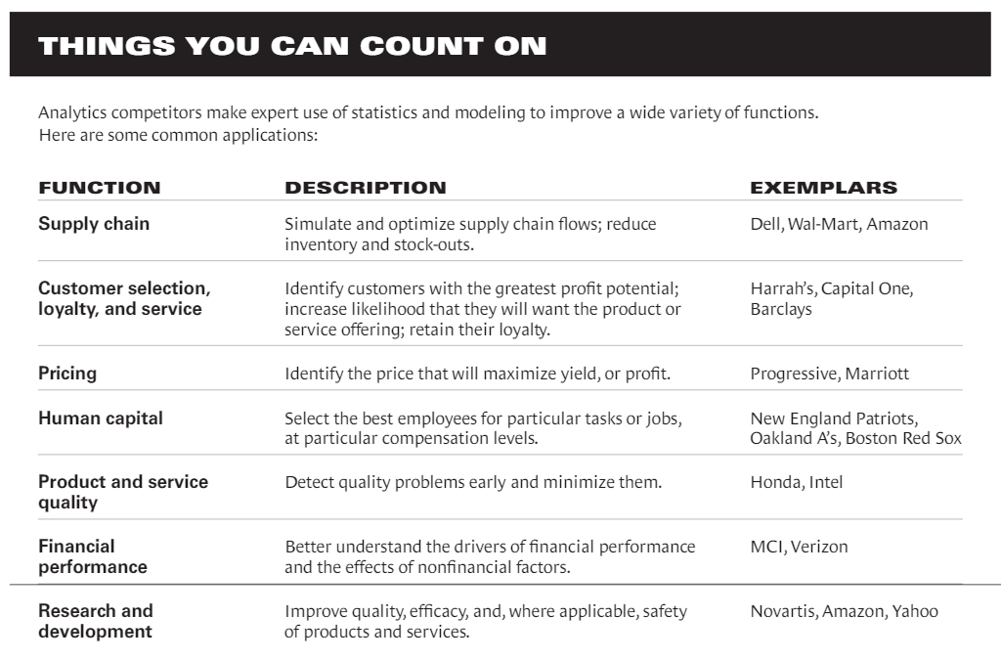

Table.No1- Lists the things a company can count on. Taken from Competing on Analytics: The New Science of Winning, By Thomas H. Davenport and Jeanne G. Harris, 2007, Harvard Business Review Press

**Conclusion**

The achievement of many organizations like Google, Capital One, Marriott and Progressive exhibits that the utilization of Analytics, Data, and Business Performance can lead to better busi­ness execution and, in reality, the upper hand. While academic work stays to be done to measure the advantages of this still better approach for working together, Research Indicates that individual analyti­cal ventures pay real profits, and overview data affirms that analyti­cal approaches are associated with the high performance. We also got to know what factors that make an analytical approach a source of com­petitive advantage by this paper. This Paper reflects Competition on Analytics, Data and Business Performance with Internal and External Processes.

**References**

[1] T.H. Davenport and J. H. Harris, Competing on Analytics: The New Science of Winning, Boston, MA, Harvard Business School Press, 2007.

[2] Big Data Analytics: Methods and Applications by Saumyadipta Pyne, B. L. S. Prakasa Rao and S. B. Rao, Springer, 2016

## [3] [International Journal of Information Management](https://www.sciencedirect.com/science/journal/02684012), [Volume 35, Issue 2](https://www.sciencedirect.com/science/journal/02684012/35/2), April 2015, Pages 137-144,Beyond the hype: Big data concepts, methods, and analytics by Amir Gandomi and Murtaza Haider

[4] The Profit Impact of Business Intelligence, By Williams, Steve Williams, Nancy, 2007

[5] Business Intelligence: the savvy manager’s guide by David Loshin, 2012

[6] Understanding Business Performance Management by Madison Jones, 2018

https:[//www.cornerstoneondemand.com/understanding-business-performance-managment](//www.cornerstoneondemand.com/understanding-business-performance-manage)

[7] Price Optimization in Retail Consumer Lending, January 7,2018

<https://www.experian.com/innovation/thought-leadership/price-optimization-paper.jsp>

[8] "Brand Management" Research Starters eNotes.com, Inc. eNotes.com 12 Dec, 2018 <http://www.enotes.com/research-starters/brand-management#research-starter-research-starter>

[9] Adaptive Business Intelligence by Zbigniew. Michalewicz, 2007

[10] R. Webby and M. O'Connor, "The Effectiveness of Decision Support Systems: The Implications of Task Complexity and DSS Sophistication," Journal of Information Technology, 9, 1994, pp. 19-28.

[11] G. L. Sanders and J. F. Courtney, "A Field Study of Organizational Factors Influencing DSS Success," MIS Quarterly, 9, 1, 1985, pp. 77-93.

[12] Thierauf, Robert J., “Effective Business Intelligence Systems”, 2001

[13] Rajeev Sharma, Peter Reynolds, Rens Scheepers, Peter B. Seddon, Graeme Shanks, “Business Analytics and competitive advantage: A review and a research agenda”, IOS press, 2010

[14] R. Kohavi, N. Rothleder, and E. Simoudis, "Emerging Trends in Business Analytics," Communications of the ACM, 45, 8, 2002, pp. 45-48.

[15] M. S. Scott Morton, "The Corporation of the 1990s: Information Technology and Organizational Transformation," New York, Oxford University Press, 1991.

[16] Ron. Sanchez, [Aimé. Heene](https://ezproxy.stevens.edu:2054/search?queryString=au%3DHeene%2C%20Aime%CC%81.&databaseList=2375,2570,173,251,1931,1875,233,1697,3313,217,638,3879,2261,1271,2260,285,143,3404,2975,2897,2259,245,2237,203,2278,1708,3867), “Competence Perspectives on managing internal processes”, 2005.